Title: **Number Conversion and PLC Basics** Test: 3

Course: Introduction to Automation Unit: Introduction to PLC CLO: 4

Name ANSWER KEY Grade 27pts Date ______________

**Objectives**

1. Student shall calculate the correct number conversion base on a number from a different number base system.
2. Student shall choose the appropriate answer for given PLC basics question.

**Assessment**

Students shall demonstrate a comprehension of the objectives listed above by scoring a minimum of 75% on this Test. Grading shall be based on the answer key.

**Instructions**

Calculate the following number to the new number base system given the value from another number base system.

1. 3310 0010 00012
2. 1110 0000 10112
3. 5110 0011 00112
4. 510 0000 01012
5. 12110 0111 10012
6. 1010 1111 17510
7. 1010 1110 17410
8. 1011 1011 18710
9. 0111 1111 12710
10. 1011 1101 18910



1. Byte C
2. Nibble B
3. Word D
4. Bit A
5. Does this rung have logical continuity? Why or why not? It does not. I:0/2 evaluates to FALSE so the result of the rung is FALSE.

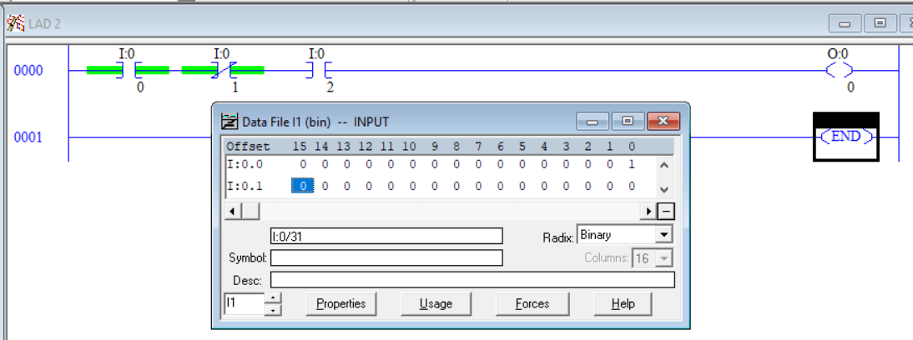Select the **best** answer to each multiple-choice question below.

1. An XIC would be used for?
   1. Checking the status of a normally open contact
   2. Testing a set of normally closed contacts
   3. Checking to see if an address is TRUE.
   4. Is used to test for a 0
2. An XIO would be used for?
3. Checking the status of a normally open contact
4. Testing a set of normally closed contacts
5. Checking to see if an address is TRUE.
6. Is used to test for a 0
7. What does the instruction TON stand for?
8. Timer over network
9. Test for ON
10. On-Delay Timer
11. Table Output Numbers
12. Fill in the state of each timer bit (0 or 1). (3pts)

|  |  |
| --- | --- |
|  | EN TRUE  TT TRUE  DN FALSE |

1. What does the instruction TOF stand for?
2. Timer over force
3. Off-Delay Timer
4. Test for OFF
5. Table Output Floats
6. Fill in the state of each timer bit (0 or 1). (3pts)

|  |  |
| --- | --- |
|  | EN FALSE  TT FALSE  DN FALSE |

1. If you want to transfer an integer value to another location, what instruction would you use?
2. CPY
3. MOV
4. TRNS
5. All the above
6. The number 123.456 is an example of an Integer.
7. True
8. False